Pseudocode to VB.NET
Y10 - Cambridge IGCSE Computer Science 0478 | 8.1 | Student booklet
Name: _______________________________ | Date: _____________

This booklet has everything you need for the lesson in one place. Work through it in order:
- Learn sections show the key slides. Read them carefully - they explain the ideas and show worked examples.
- Task sections are where you practise. Each task uses what the slides just before it taught you.
- Tasks build up from pseudocode to writing your own VB.NET program. Task 6 uses real Cambridge 0478 Paper 2 questions and is homework.
Learn Starter
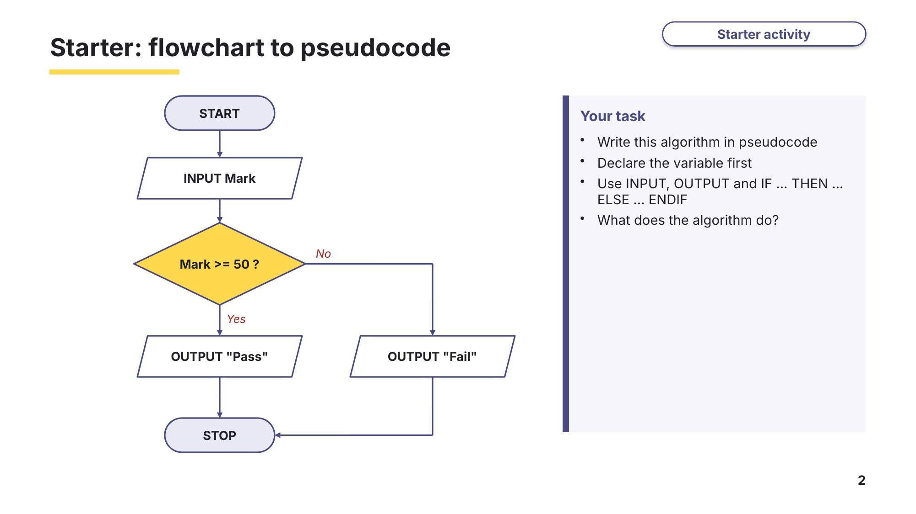
Slide 2 - Starter: flowchart to pseudocode
Task 1 Starter: flowchart to pseudocode [4 marks]
Look at the flowchart on the starter slide. It inputs a Mark and outputs "Pass" if the mark is 50 or more, otherwise "Fail". Write the algorithm in Cambridge pseudocode. Declare the variable first.

Learn Pseudocode recap
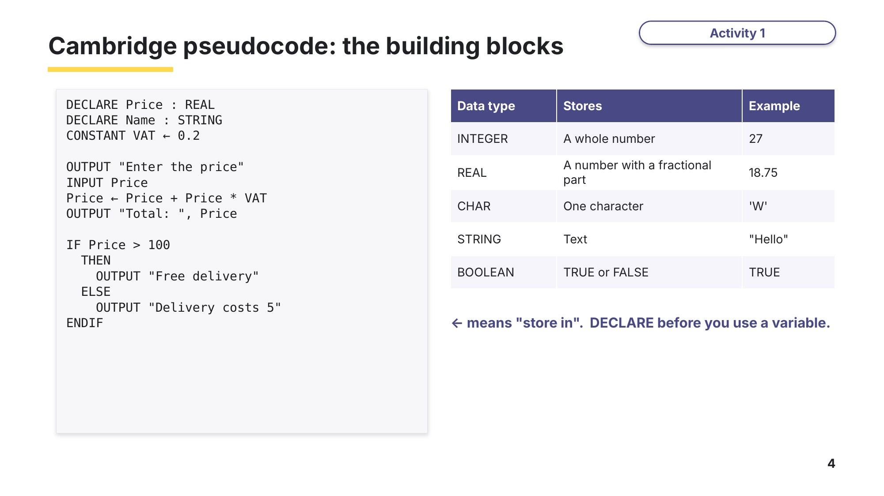
Slide 4 - Cambridge pseudocode: the building blocks
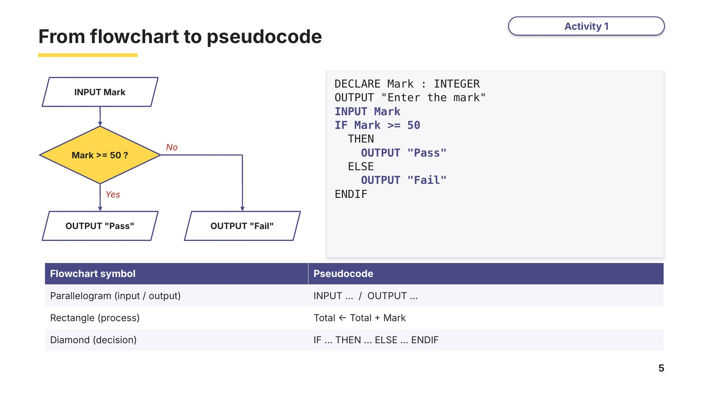
Slide 5 - From flowchart to pseudocode

Learn Meet VB.NET
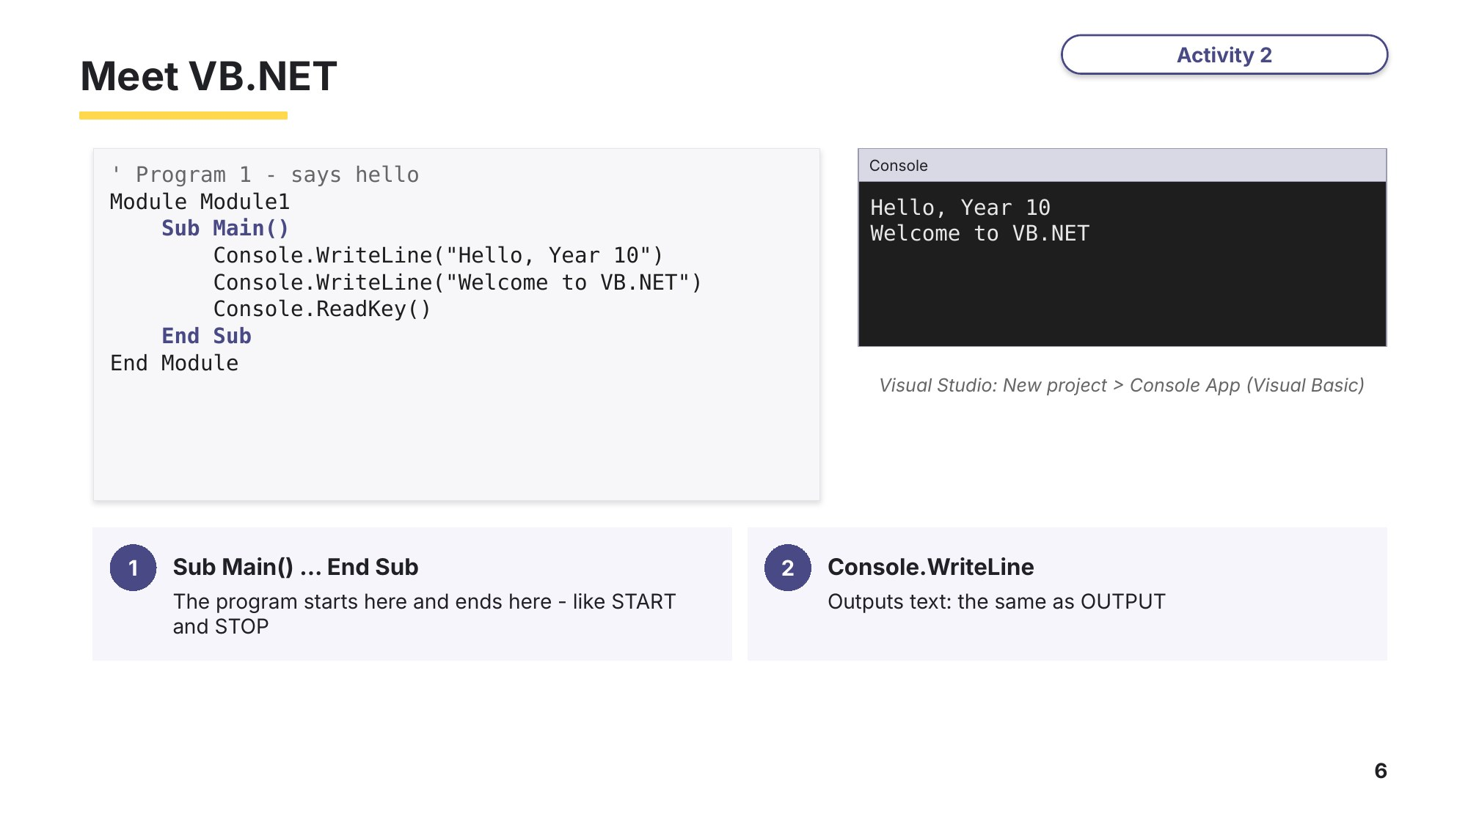
Slide 6 - Meet VB.NET
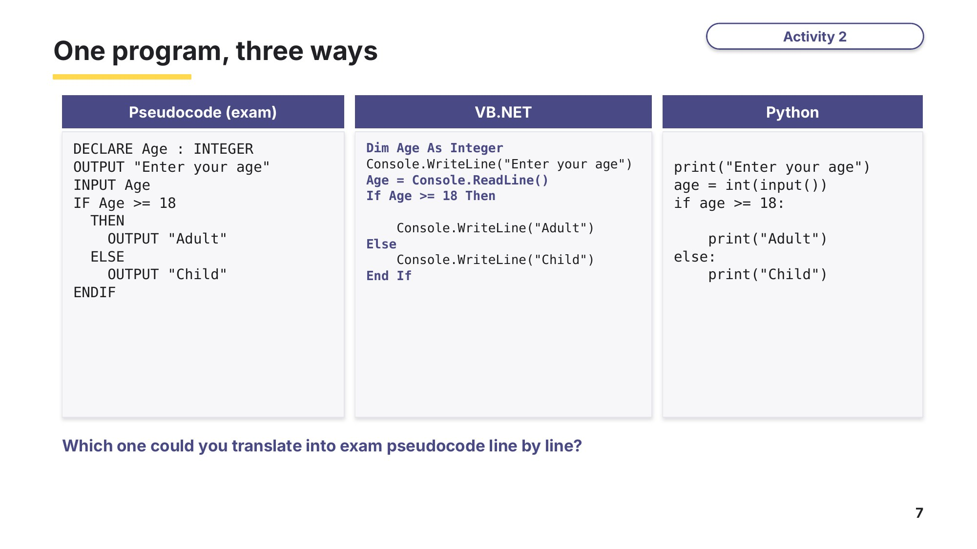
Slide 7 - One program, three ways
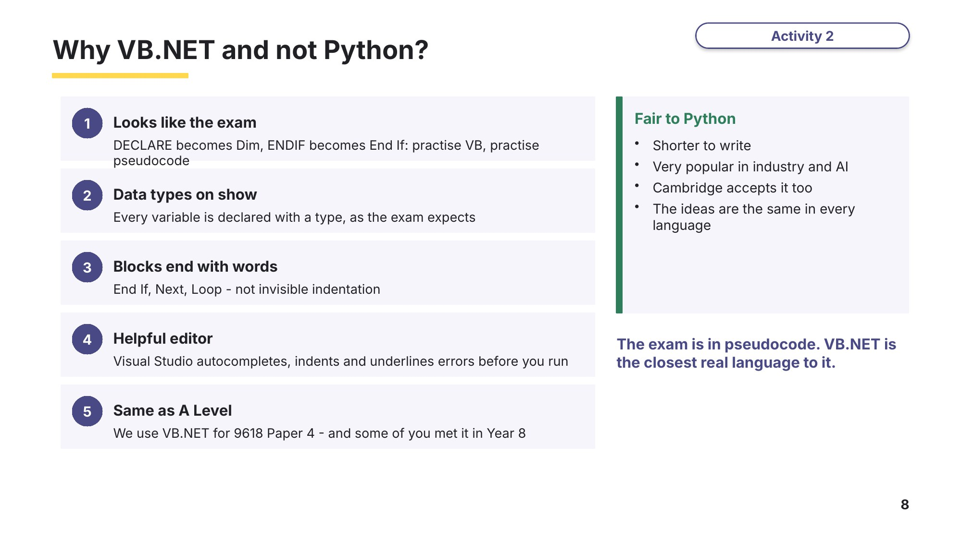
Slide 8 - Why VB.NET and not Python?

Learn Writing statements in VB.NET
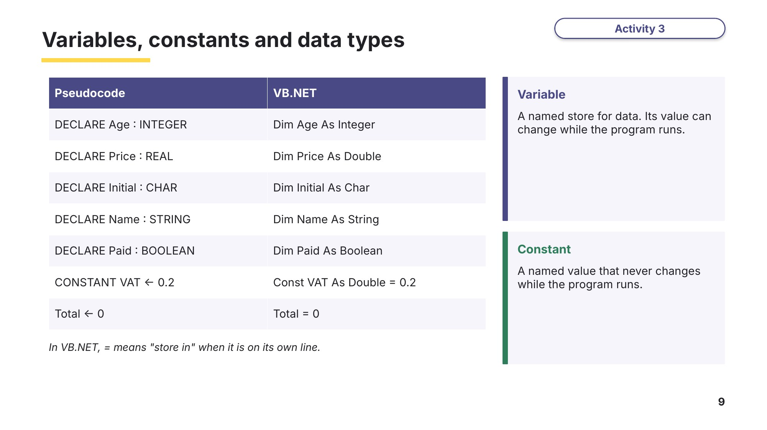
Slide 9 - Variables, constants and data types
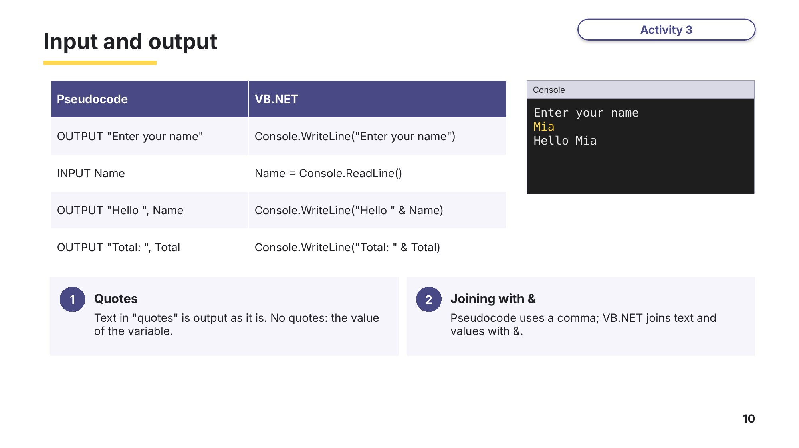
Slide 10 - Input and output
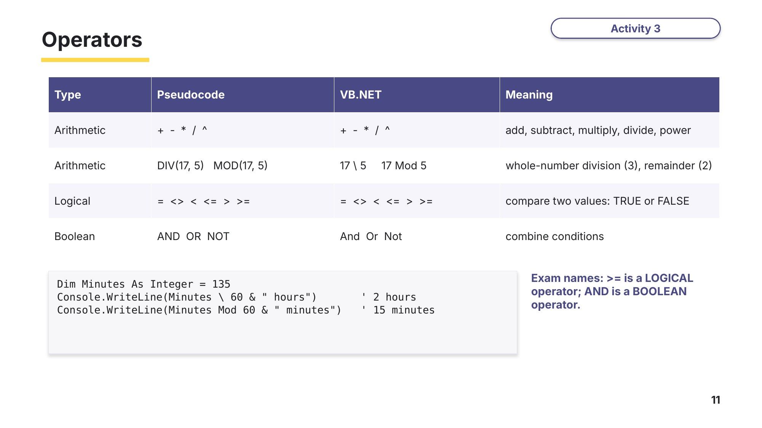
Slide 11 - Operators

Task 2 Pseudocode to VB.NET [8 marks]
Write each pseudocode statement as a VB.NET statement.
 | Pseudocode | VB.NET
1 | DECLARE Name : STRING
2 | DECLARE Height : REAL
3 | CONSTANT MaxScore ← 100
4 | OUTPUT "What is your name?"
5 | INPUT Name
6 | Total ← Score1 + Score2
7 | OUTPUT "Your total is ", Total
8 | IF Total > MaxScore

Learn Selection in VB.NET
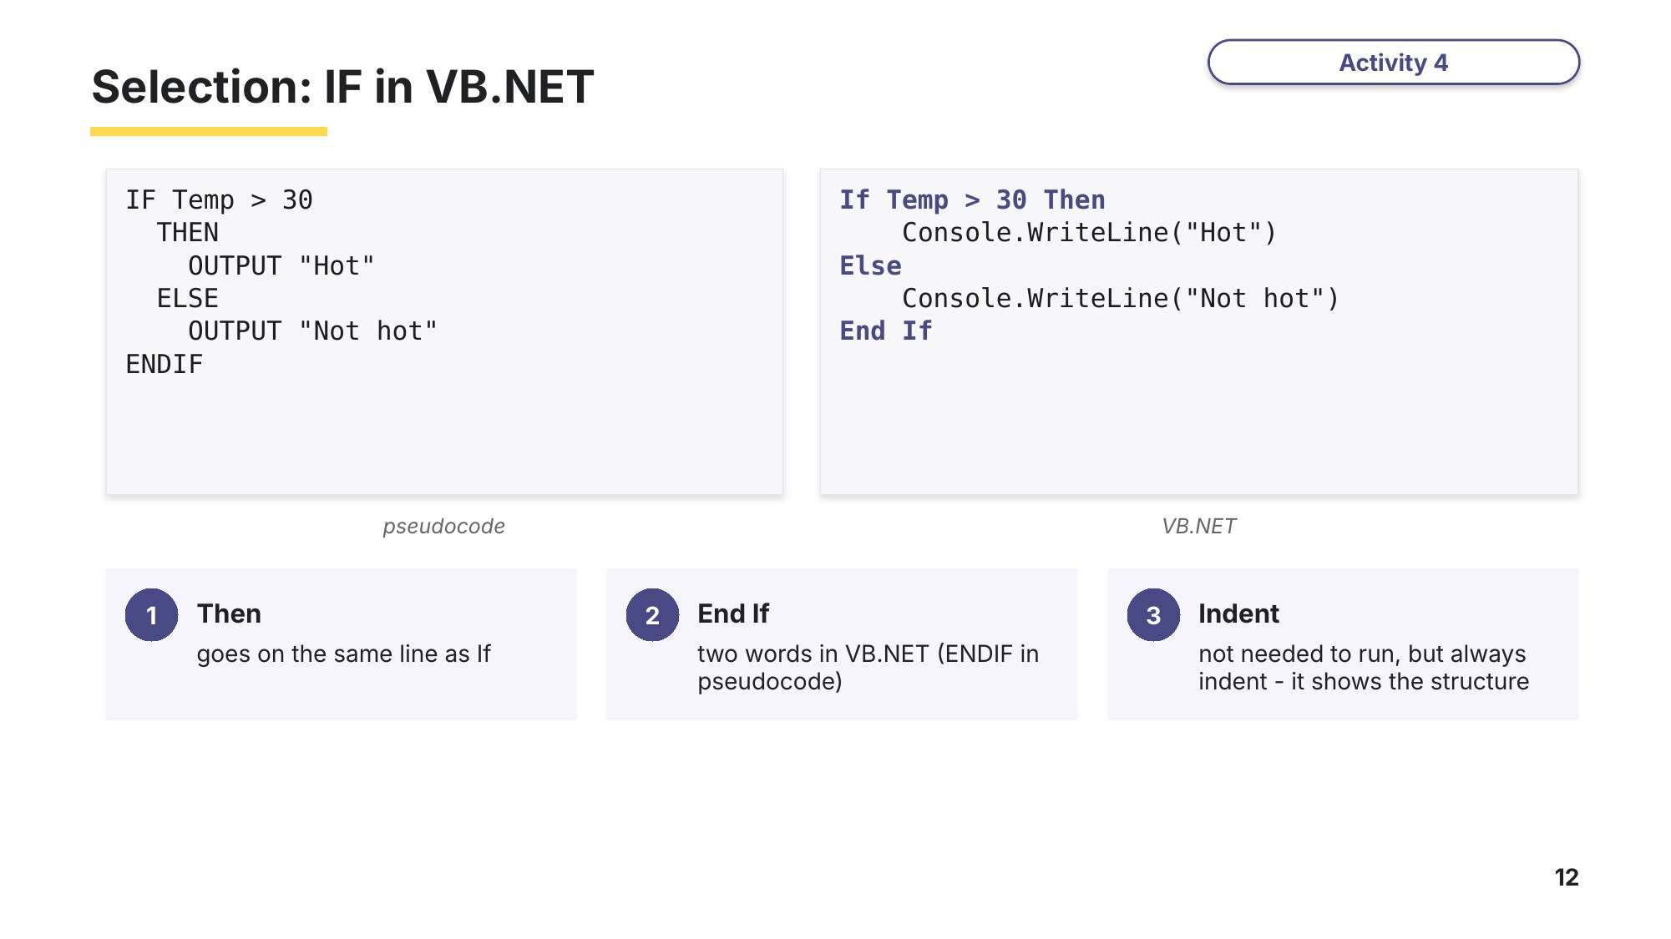
Slide 12 - Selection: IF in VB.NET
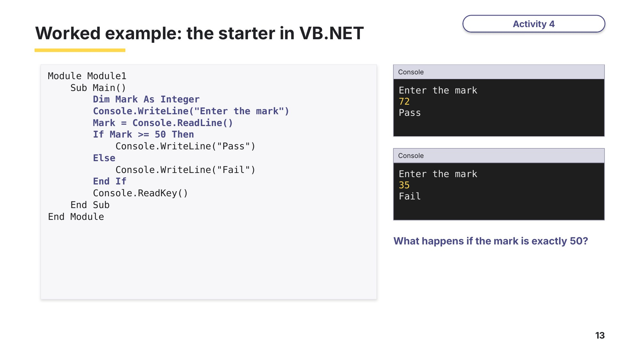
Slide 13 - Worked example: the starter in VB.NET
Task 3 Trace a VB.NET program [6 marks]
01 Module Module1
02 Sub Main()
03 Const Limit As Integer = 25
04 Dim Temp As Integer
05 Dim Diff As Integer
06 Console.WriteLine("Enter the temperature")
07 Temp = Console.ReadLine()
08 Diff = Temp - Limit
09 If Temp > Limit Then
10 Console.WriteLine("Too hot by " & Diff)
11 Else
12 Console.WriteLine("OK")
13 End If
14 Console.ReadKey()
15 End Sub
16 End Module
(a) Identify the constant in the program and give its value. [1]

(b) The program is run three times. Complete the table for each input. [3]
Run | Temp (input) | Diff | Output
1 | 30
2 | 25
3 | 12
(c) Write line 08 as a pseudocode statement. [1]

(d) Explain why Limit is declared as a constant and not as a variable. [1]

Learn Debugging
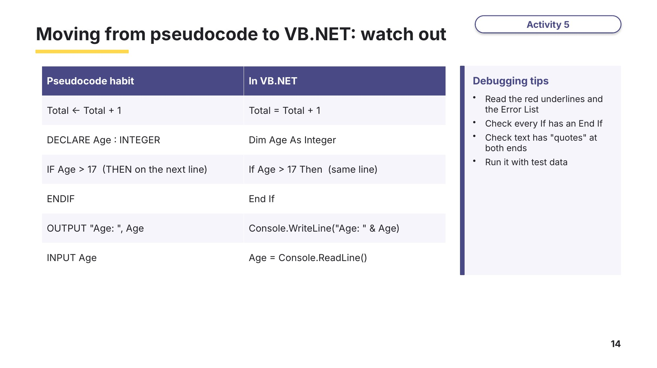
Slide 14 - Moving from pseudocode to VB.NET: watch out
Task 4 Debug: find the four errors [4 marks]
This program should output "Well done" for a score of 50 or more, otherwise "Try again". It has four errors, all from writing pseudocode habits in VB.NET. Open the starter file Task4_Debug.vb, find the errors, fix them and run the program. Then complete the table.
01 Module Module1
02 Sub Main()
03 Dim Score As Integer
04 Console.WriteLine("Enter your score")
05 Score ← Console.ReadLine()
06 If Score >= 50
07 Console.WriteLine("Well done")
08 Else
09 Console.WriteLine(Try again)
10 ENDIF
11 Console.ReadKey()
12 End Sub
13 End Module
Line | Correct VB.NET
Task 5 Build a program [8 marks]
A shop needs a program for its till. The program must:
- input the price of an item and the amount the customer pays
- output "Not enough money" if the amount paid is less than the price
- otherwise calculate and output the change, with a suitable message.
(a) Write the algorithm in pseudocode. Declare your variables with suitable data types. [4]
(b) Open the starter file Task5_Change.vb and write the program in VB.NET. Test it with: price 4.50 paid 10 (change 5.5), price 8 paid 5 (not enough), price 3 paid 3 (change 0). [4]
Extension: if the change is 20 or more, also output "Please count your change carefully".

Learn Exam technique
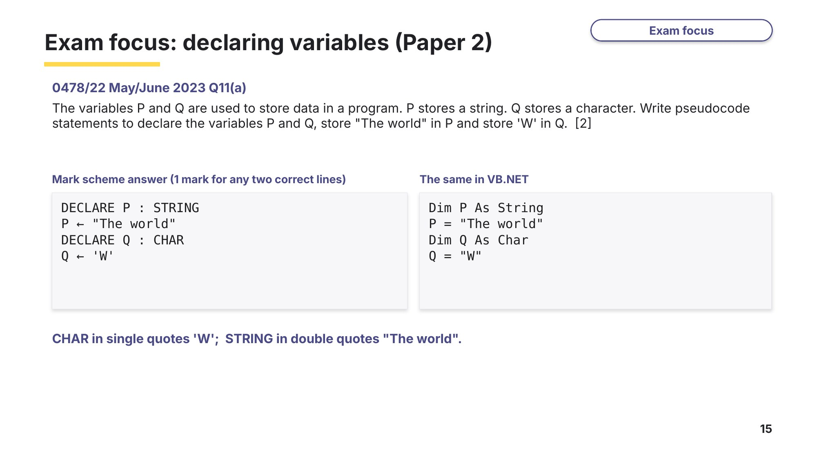
Slide 15 - Exam focus: declaring variables (Paper 2)
Task 6 Real exam questions - homework [13 marks]
All questions are from Cambridge IGCSE Computer Science 0478 Paper 2.
(a) Four operators and three types of operator are shown. Draw one or more lines from each operator to its correct operator type. [4]
0478/21 October/November 2024 Q3.
Operator |  | Operator type
>= |  | Boolean
AND |  | Arithmetic
DIV |  | Logical
+
(b) State what is meant by the data types integer and real. Give an example of each. [4]
0478/21 May/June 2024 Q3.
Data type | Meaning | Example
Integer
Real
(c) Explain how variables and constants should be used when creating and running a program. [3]
0478/22 October/November 2023 Q5.

(d) A holds a whole number and B holds text. Write pseudocode statements to declare the variables A and B. [2]
0478/21 May/June 2025 Q9(a).

Extension (not an exam question): write your answer to (d) in VB.NET.

Learn Review
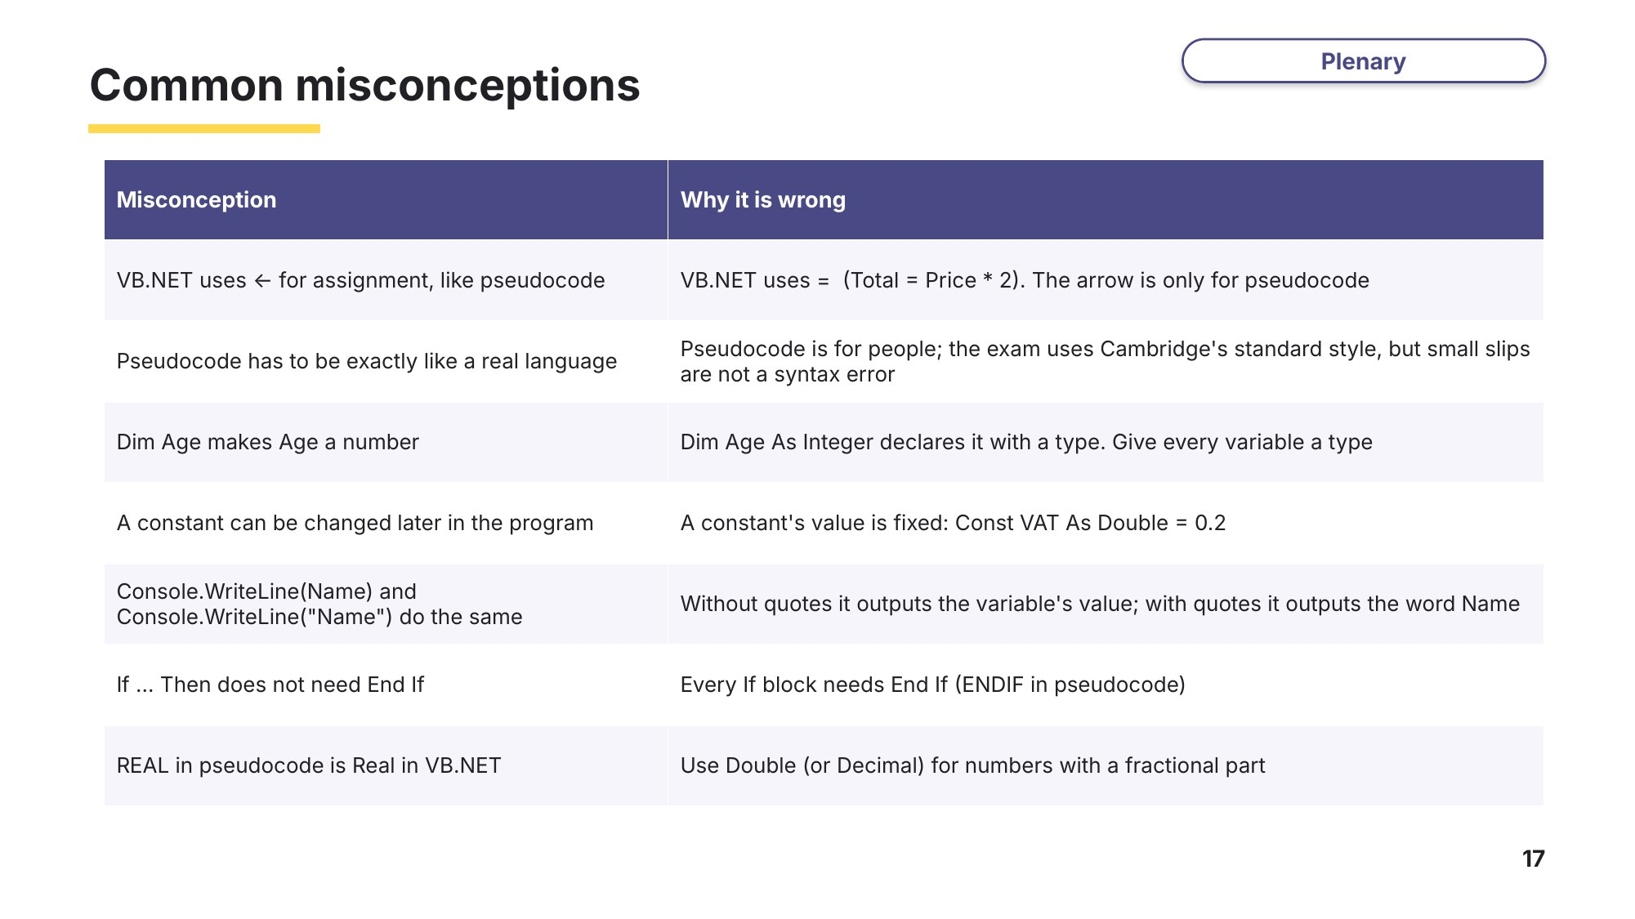
Slide 17 - Common misconceptions
Exit question
Write each pseudocode statement in VB.NET.
(a) DECLARE Score : INTEGER [1]

(b) CONSTANT Pi ← 3.142 [1]

(c) INPUT Total [1]

(d) IF Total > 10 THEN ... ENDIF (write the first and last lines) [2]

